# Written Part (20 points)

## Q.1

Suppose a camera has 450 lines per frame, 520 pixels per line, and 25 Hz frame rate. The color sub sampling scheme is 4:2:0, and the pixel aspect ratio is 16:9. The camera uses interlaced scanning, and each sample of Y, Cr, Cb is quantized with 8 bits.

1. What is the bit-rate produced by the camera? (2 points).
2. Suppose we want to store the video signal on a hard disk, and, in order to save space, the signal is re-quantized so that each channel (Y, Cr, Cb) uses 6 bits. What is the minimum size of the hard disk required to store 10 minutes of video (3 points).

A.1

Bit-rate produced by the camera is calculated as:

Hence,

A.2

For storing the video, the luminance and chrominance channels should be changes to 4:2:0, where the average bits for a pixel should be changed to the followings:

Hence, the total bits used for storing is

## Q2

The following sequence of real numbers has been obtained sampling an audio signal: 1.8, 2.2, 2.2, 3.2, 3.3, 3.3, 2.5, 2.8, 2.8, 2.8, 1.5, 1.0, 1.2, 1.2, 1.8, 2.2, 2.2, 2.2, 1.9, 2.3, 1.2, 0.2, -1.2, -1.2, -1.7, -1.1, -2.2, -1.5, -1.5, -0.7, 0.1, 0.9 Quantize this sequence by dividing the interval [-4, 4] into 32 uniformly distributed levels (place the level 0 at -3.75, the level 1 at -3.5, and so on. This should simplify your calculations).

1. Write down the quantized sequence. (4 points)
2. How many bits do you need to transmit it? (1 points)

A.1

Based on the definition, all the intervals are listed as follows:

|  |  |  |  |  |  |  |  |
| --- | --- | --- | --- | --- | --- | --- | --- |
| Level 0 | Level 1 | Level 2 | Level 3 | Level 4 | Level 5 | Level 6 | Level 7 |
| [-4, -3.75] | (-3.75, -3.5] | (-3.5, -3.25] | (-3.25, -3] | (-3, -2.75] | (-2.75, -2.5] | (-2.5, -2.25] | (-2.25, -2] |
| Level 8 | Level 9 | Level 10 | Level 11 | Level 12 | Level 13 | Level 14 | Level 15 |
| (-2, -1.75] | (-1.75, -1.5] | (-1.5, -1.25] | (-1.25, -1] | (-1, -0.75] | (-0.75, -0.5] | (-0.5, -0.25] | (-0.25, 0] |
| Level 16 | Level 17 | Level 18 | Level 19 | Level 20 | Level 21 | Level 22 | Level 23 |
| (0, 0.25] | (0.25, 0.5] | (0.5, 0.75] | (0.75, 1] | (1, 1.25] | (1.25, 1.5] | (1.5, 1.75] | (1.75, 2] |
| Level 24 | Level 25 | Level 26 | Level 27 | Level 28 | Level 29 | Level 30 | Level 31 |
| (2, 2.25] | (2.25, 2.5] | (2.5, 2.75] | (2.75, 3] | (3, 3.25] | (3.25, 3.5] | (3.5, 3.75] | (3.75, 4] |

Hence, the given data are quantified to:

|  |  |  |  |  |  |  |  |  |
| --- | --- | --- | --- | --- | --- | --- | --- | --- |
| Input | 1.8 | 2.2 | 2.2 | 3.2 | 3.3 | 3.3 | 2.5 | 2.8 |
| Level | Level 23 | Level 24 | Level 24 | Level 28 | Level 29 | Level 29 | Level 26 | Level 27 |
| Output | 2 | 2.25 | 2.25 | 3.25 | 3.5 | 3.5 | 2.75 | 3 |
| Input | 2.8 | 2.8 | 1.5 | 1 | 1.2 | 1.2 | 1.8 | 2.2 |
| Level | Level 27 | Level 27 | Level 22 | Level 20 | Level 20 | Level 20 | Level 23 | Level 24 |
| Output | 3 | 3 | 1.75 | 1.25 | 1.25 | 1.25 | 2 | 2.25 |
| Input | 2.2 | 2.2 | 1.9 | 2.3 | 1.2 | 0.2 | -1.2 | -1.2 |
| Level | Level 24 | Level 24 | Level 23 | Level 25 | Level 20 | Level 16 | Level 11 | Level 11 |
| Output | 2.25 | 2.25 | 2 | 2.5 | 1.25 | 0.25 | -1 | -1 |
| Input | -1.7 | -1.1 | -2.2 | -1.5 | -1.5 | -0.7 | 0.1 | 0.9 |
| Level | Level 9 | Level 11 | Level 7 | Level 10 | Level 10 | Level 13 | Level 16 | Level 19 |
| Output | -1.5 | -1 | -2 | -1.25 | -1.25 | -0.5 | 0.25 | 1 |

A.2

There are 32 levels, which is , resulting in 5 bits for each sample. Moreover, there are 32 samples, leading to , in all.

## Q3

Temporal aliasing can be observed when you attempt to record a rotating wheel with a video camera. In this problem, you will analyze such effects. Assume there is a car moving at 36 km/hr and you record the car using a film, which traditionally record at 24 frames per second. The tires have a diameter of 0.4244 meters. Each tire has a white mark to gauge the speed of rotation.

1. If you are watching this projected movie in a theatre, what do you perceive the rate of tire rotation to be in rotations/sec? (2 points)
2. If you use your camcorder to record the movie in the theater and your camcorder is recording at one third film rate (i.e. 8 fps), at what rate (rotations/sec) does the tire rotate in your video recording (5 points)
3. If you use an NTSC camera with 30 fps, what is the maximum speed that the car can go at so that you see no aliasing in the recording (3 points)

A.1 The current speed of the moving car is at 36 km/hr, which is 10 m/s. The tires have a diameter of 0.4244 meters, denoting the perimeter of the wheel is 1.33 m. Therefore, the wheel will rotate around 10 m / 1.33 m = 7.5 times in a second. The recording frame of the film is 24 frames / second, where the frequency is larger than two times of the rotation frequency. Hence, the rate of tire rotation in the film is the same an its real rotation speed, which should be 7.5 rotations / sec.

A.2 The wheel rotations 7.5 times in a second, as calculated in A.2, which is 2700° in a second.

Based on the frequency, the details of each frame can be listed as follows:

|  |  |  |  |  |
| --- | --- | --- | --- | --- |
| Frame | Rotation | Accumulated Rotation | Recorded Rotation | Difference |
| 1 | 337.5 | 337.5 | 337.5 | -22.5 |
| 2 | 337.5 | 675 | 315 | -22.5 |
| 3 | 337.5 | 1012.5 | 292.5 | -22.5 |
| 4 | 337.5 | 1350 | 270 | -22.5 |
| 5 | 337.5 | 1687.5 | 247.5 | -22.5 |
| 6 | 337.5 | 2025 | 225 | -22.5 |
| 7 | 337.5 | 2362.5 | 202.5 | -22.5 |
| 8 | 337.5 | 2700 | 180 | -22.5 |

Hence, in each frame, the position of the tire looks like rotate backward 22.5°. The rotation of the wheel should be viewed in a rate of -0.5 rotations / sec.

A.3 Based on the Nyquist’s sampling theorem, the sampling speed should be twice as the real frequency. The sampling speed for a NTSC camera is 30 fps. Which means, the rate of wheel should be at 15 rotations at most. For the given diameter of the wheel, the total distance that the wheel will run in a hour should be 15 rotations * 0.4244 meters * * 3600 s / 1000m = 72 km / hr.

# Programming Part (130 points)

The Implementation of this assignment is organized as follows:

* Header Files
  + Assignment1Code.h: the main class definition based on QT
  + AntiAliasingOperator.h: A thread class to implement anti-aliasing
  + FileLoader.h: A thread class to implement data loading
  + SeamCarvingOperator.h: A thread class to implement seam carving.
* Source Files
  + main.cpp: main function
  + Assignment1Code.cpp: implementation of Assignment1Code.h
  + AntiAliasingOperator.cpp: implementation of AntiAliasingOperator.cpp
  + FileLoader.cpp: implementation of FileLoader.cpp
  + Initialization.cpp: implementation of initialization part of Assignment1Code.h
  + SeamCarvingOperator.cpp: implementation of SeamCarvingOperator.h
  + SlotFunction.cpp: implementation of slot functions of Assignment1Code.h
* Form Files
  + Assignment1Code.ui: QT GUI form
* Resource Files
  + Assignment1Code.qrc: QT resource file

And the following picture is the implementation example:

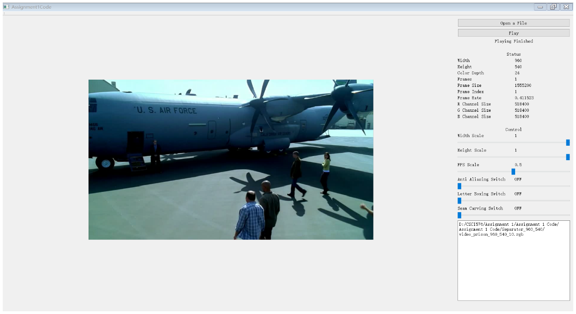

# Implementation (70 points)

* Button
  + Open a File: load a file in .rgb form
  + Play: process the data stream read from .rgb file
* Status
  + Width: the width of the frame
  + Height: the height of the frame
  + Color Depth: the color depth of the frame
  + Frames: total frames of the data stream
  + Frame Size: the size of the frame in bytes
  + Frame Index: current frame index
  + Frame Rates: current frame rate
  + R Channel Size: red channel size in bytes
  + G Channel Size: green channel size in bytes
  + B Channel Size: blue channel size in bytes
* Control
  + Width Scale: control the factor to scale the frame horizontally
  + Height Scale: control the factor to scale the frame vertically
  + FPS Scale: control the factor to scale the frame rates
  + Anti Aliasing Switch: control whether to conduct anti-aliasing
  + Letter Boxing Switch: control whether to conduct non-linear mapping
  + Seam Carving Switch: control whether to conduct seam carving

Implementation of loading files

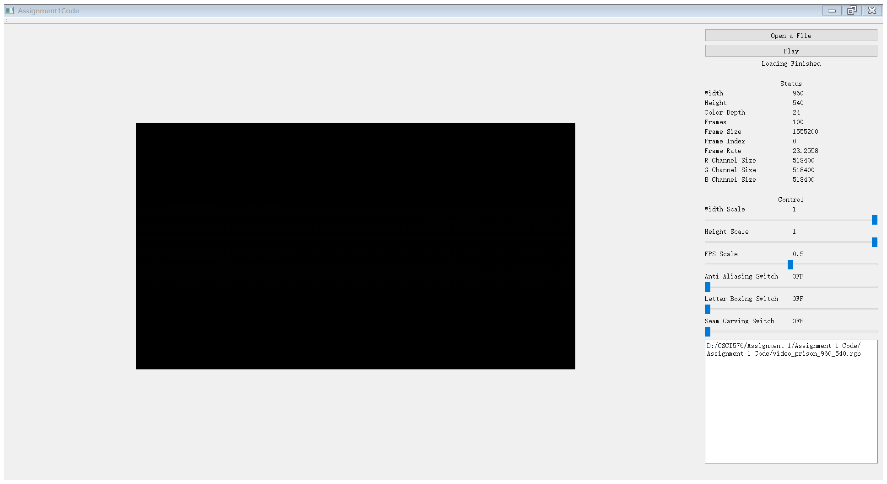

Implementation of resizes

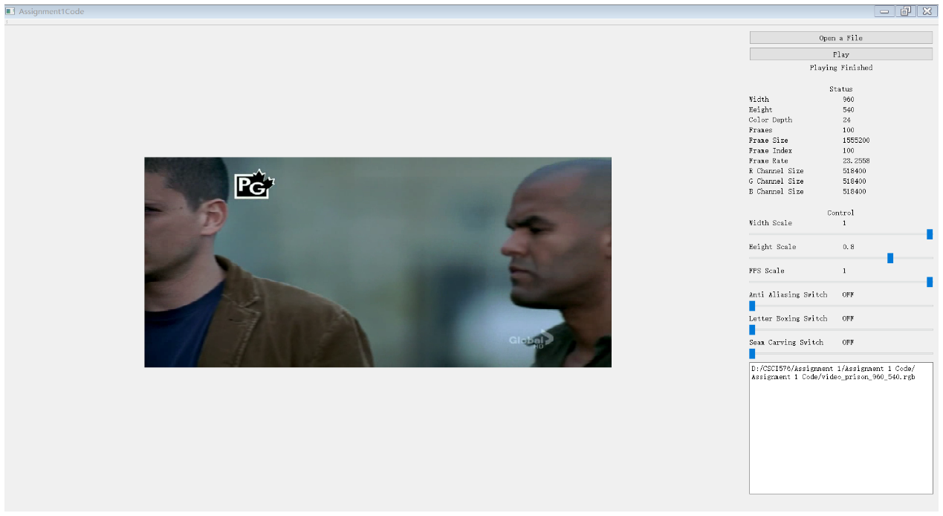

Implementation of anti-aliasing

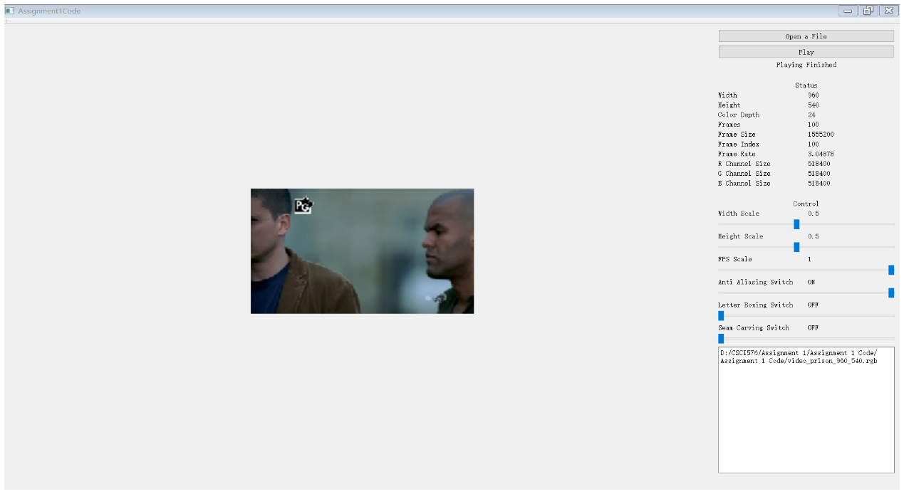

# Analysis Part A (30 points)

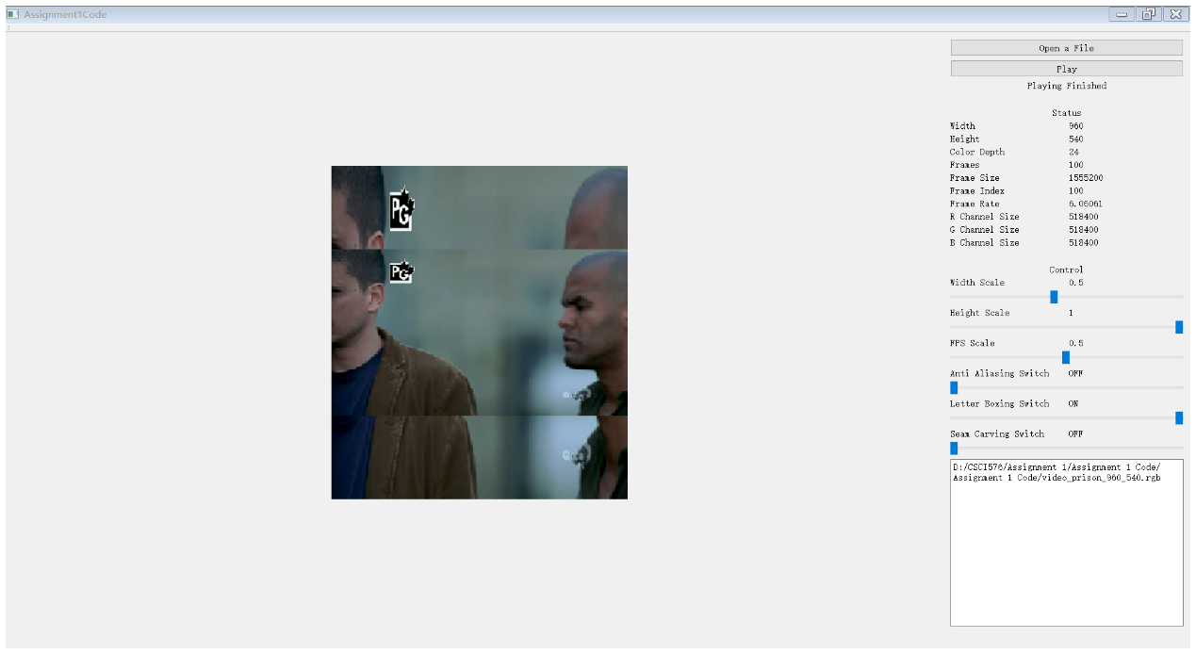

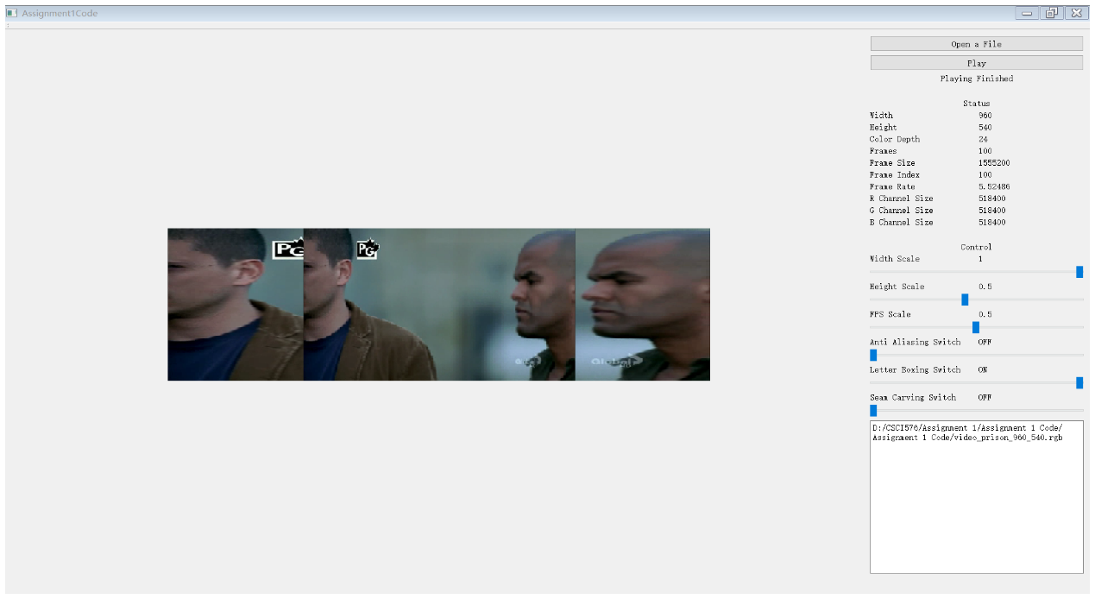

# Analysis Part B (30 points)

Seam Carving Gradient Result

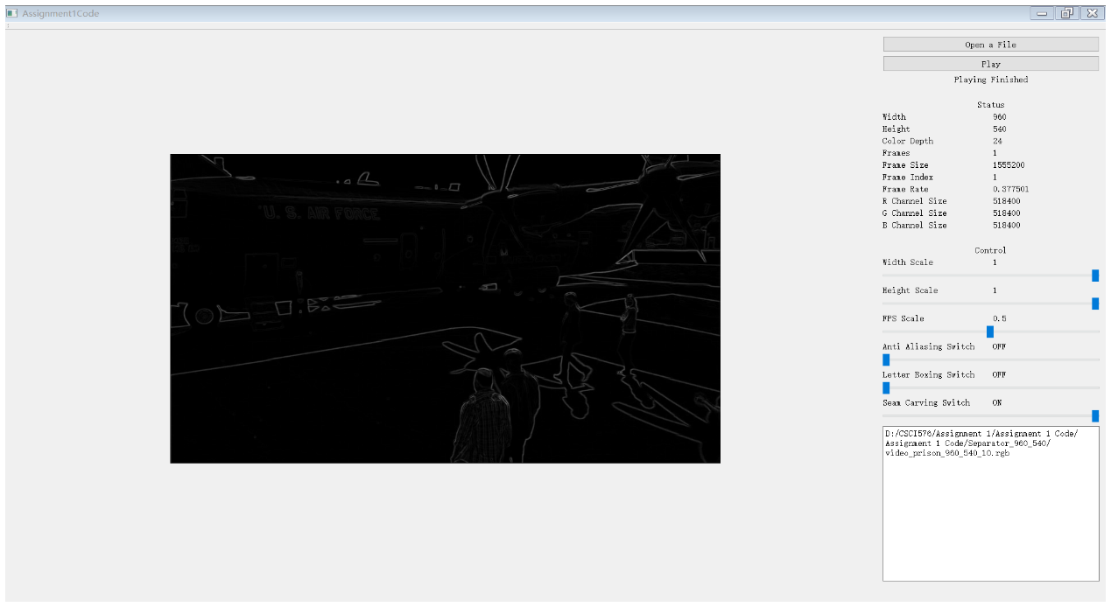

Seam Carving Energy Matrix Result

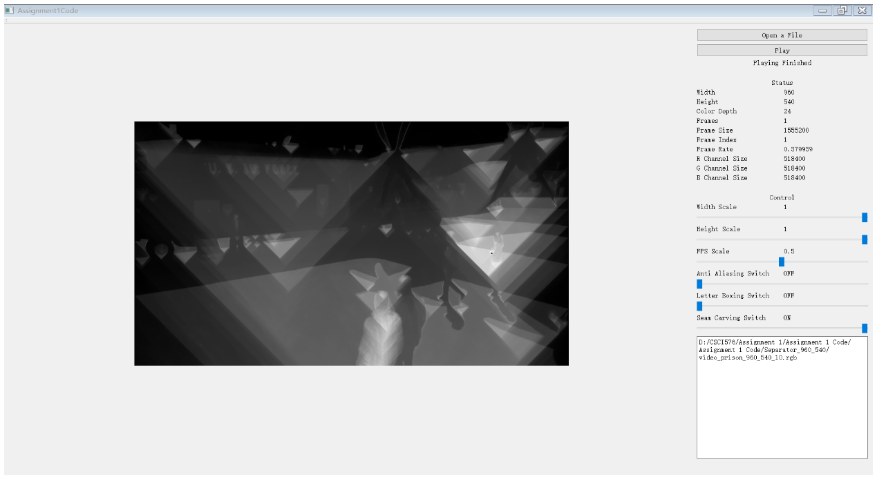

# Optional Extra Credit